Integrated Scorecard

(Performance and strategy management using integration of powerful Scorecards)

Detailed Design
Version 1.0
Date: 04-Nov-2007
Table of Contents
Table of Contents ii
Revision History iii
1. Introduction 1
1.1 Purpose 1
1.2 Intended Audience and Reading Suggestions 1
2. Overall Description 1
2.1 Product Features 1
2.2 System Components 3
2.2.1 The full system 3
2.2.2 The major subsystems of the main system 4
2.2.3 The Interactions between the subsystems 6
2.2.4 View of the subsystems and layers 8
2.3 Operating Environment 16
2.4 Design and Implementation Constraints 17
2.5 User Documentation 17
2.6 Assumptions and Dependencies 17
3. System Features 18
3.1 System Feature 1 18
3.2 System Feature 2 (and so on) 19
4. External Interface Requirements 19
4.1 User Interfaces 19
4.2 Hardware Interfaces 19
4.3 Software Interfaces 19
4.4 Communications Interfaces 19
5. Other Nonfunctional Requirements 20
5.1 Performance Requirements 20
5.2 Safety Requirements 20
5.3 Security Requirements 20
5.4 Software Quality Attributes 20
6. Other Requirements 20
Appendix A: Glossary 21
Appendix B: Analysis Models 21
Appendix C: Issues List 21

Revision History
Name | Date | Reason For Changes | Version
 | 20-Oct-07 | Initial document.First draft | 1.0

Introduction

Purpose
The purpose of this document is to provide the detailed design to the system “Integrated Office Scorecard”. Initially it will describe the system in a high level and later the high level components will be detailed.

Intended Audience and Reading Suggestions
This document is intended to be used by the development team for the construction.

High Level Design

Product Features
Introduction: The goal of the project is to develop a system to help organizations track their performance, growth, strengths and targets using a set of scorecards such as the competency scorecard, balanced scorecard and performance scorecard. Scorecard is similar to a progress report card. Through an exercise, each entity in an organization is given a rank on the scores gained in a set of measures similar to a student being ranked on the marks he gained in a set of subjects. These scorecards will be integrated to provide a final integrated scorecard for an employee, for a team, project, division and the company as a whole. Using the data derived from these scorecards so much of valuable information can be collected by the management to set up strategies that will spearhead the organization to perform at its highest potential to achieve the desired targets, mission and vision. This software aims to reduce the gap between employees and business by providing metrics to measure the power and contribution of each employee in the growth of an organization and using these metrics provide a justified method of rewarding talents and a scientific approach to grow and nurture talent in the organization. The system comprises of four scorecards explained below.

Balanced Scorecard: The Balanced Scorecard is a management concept that says there is/should be more that one imperative for success. At high level it considers success, or effectiveness, to be a balance across financial, strategic, customer and internal process compliance. This method has been invented in 1992, by Robert Kaplan and David Norton. The main use of this scorecard is to have a mechanism, by which the growth of an organization can be measured in the correct way. Most organizations fail to perform in its best not because of bad performance, but everyone performing best for himself, for his growth, for his teams growth, while not concentrating whether his performance is helping the organization growth. Simply put, goal of the individuals are not aligned to the goals of the organization. This scorecard provides an approach, by which each individual is aligned to the goals of the organization, everyone performing towards a single goal. From this scorecard also each entity will get a score out of this scorecard, which will be compared against the ideal score.

Competency Scorecard: This scorecard measures the skill levels of each entity in the organization and provides a systematic way to develop talent in the organization. If the skill level of each employee is measured through a well defined system, then it is possible to expect the performance of a team or a division for performing a special task. Each employee is given a chance to know his strengths and weaknesses. There is so many information that the management can derive from this data such as analysing the strength of a competency organization wide, how many employees that require a certain skill, lack it so that they can be trained, search the employees who have the highest proficiency for a particular skill etc. Each entity will get a score out of this scorecard, which will be compared against the ideal score.

Performance Scorecard: This subsystem implements the performance appraisal system in an organization and attempts to eliminate various flaws usually found in the normal appraisal process. This is a system which measures the performance of employees in the last appraisal period, consolidates inputs from the employee and their managers and derives a score by which the employee is rewarded. Also the action plans are set up by which the employee is given chance to improve his performance or use his expertise to train less experienced. This system also provides valuable input to the management by highlighting best performers, to be assigned important roles. Another advantage is that high performing teams can be identified and rewarded. Out of performance scorecard, a score, a numerical result will be given to each entity in the organization.

Integrated Scorecard: The scorecards mentioned above obtain their full power when consolidated. The competency scorecard provides a way to see what an employee is capable of, and makes provision to grow the talent. The balanced second makes sure that each employee’s performance is aligned to the goal of the company and so growth of each employee feeds the growth of the company, while it also allows the company to monitor its growth by monitoring a manageable set of measures for growth. Performance scorecard sees what the employee has done in the past period, and tracks his growth over the past period. When integrating these three scorecards a final scorecard called “Integrated scorecard” is derived. This integrated scorecard is an automatic scorecard that is derived using a set of simple rules such as what is the weight of competency score, balanced scorecard score and performance scorecard in deriving the final score. Each entity whether employee, team, division, branch will have a final score, by which future decisions will be taken by the management on growing an entity or assigning it important tasks.

System Components
This section divides the full system into manageable subsystems to reduce complexity of the system and to provide for easy system maintenance. How the system is divided into subsystems, how the systems interact with each other will be detailed here.

The full system

This is the full system currently viewed as a whole box

Integrated Office Scorecard

The major subsystems of the main system
After analyzing the requirements, the major components listed below are identified.

Integrated Office Scorecard

User Interface

System Prerequisites
Mailing System

Competency management System
Performance Management System

Balanced Scorecard Management System

Integration Management System

Scorecard Management System

- System Prerequisites
  - All the features that are needed to maintain the system, regardless of whether we use competency system, or any other system will fall under this section. When this subsystem is detailed, the requirements for this system will be detailed. A few of the requirements that fall under this section are managing users, global parameters, organization hierarchies. Most of the other subsystems need to interact with this system
- Competency Management System
  - Restricted to managing competencies and competency exercise
- Performance Management System
  - Restricted to managing performance appraisal system
- Balanced Scorecard Management System
  - Restricted to managing balanced scorecard operation
- Integration Management System
  - Restricted to managing integration of the different scorecard systems. In this version of the software, this will integrate competency scorecard, performance scorecard and balanced scorecard. In later versions it can integrate if a new scorecard management system is added.
- Scorecard Management System
  - The most important subsystem. This will get required parameters from the different “Scorecard Type” systems and will create scorecards and send it to the requested system
- User Interface
  - The user interface will be a separate system. This is created this way, so that if the existing UI is to be replaced with a new UI, it should be possible to do very easily.
- Data base system
  - All the calls to the database will be from this system. This system also includes the database, the tables, and the procedures inside the database.

The Interactions between the subsystems
The figure below lists how the systems interact within each other and which subsystems should not interact with each other.

Integrated Office Scorecard

System Prerequisites
Competency management System
Performance Management System

Balanced Scorecard Management System

Integration Management System

Scorecard Management System

User Interface

Mailing System

A few details of the interaction between the systems

- User interface is a separate system. It should not be tightly related with any other systems. This means, if this user interface system is to be removed, it should not take away any part of other systems. Other systems will function in full.
- Mailing system is a separate system that takes a set of parameters, and does its job: sending mails. The interaction of configuring mails is done by each scorecard type subsystem. It interacts with the different scorecard type systems which will give inputs to send mails. Even without the mailing system, all other systems should work. The scorecard type subsystems will push data to mailing system, using which it will send mails. The UI is used to
- The separate scorecard type systems do not interact with each other. There is no relation between them. This means that even if one scorecard type system is to be removed from the full system, the system should work perfectly fine without any issues. This also means that a new scorecard type system can also be added without disturbing the entire system
- The scorecard management system is a separate service, which will be made use by the scorecard type systems. This will get a set of parameters from these systems, create and format a scorecard and will send it to the scorecard type systems. They will pass the object on to the UI which will show the scorecard to the user. As the diagram shows, the scorecard component is independent of the organization or anything. It doesn’t interact with the prerequisites, mailing system or with the user interface. These systems do not know the existence of scorecard system. The scorecard system only interacts with the scorecard type systems.

Low Level Design

Development Life Cycle
The software uses the incremental model development life cycle. At specified intervals, fully functional versions of the software will be released, with more functionalities that the previous version.

Database Handling
Before the development, a clearly defined database should be created, as changes in the database might result in too much of rework.

User Interface
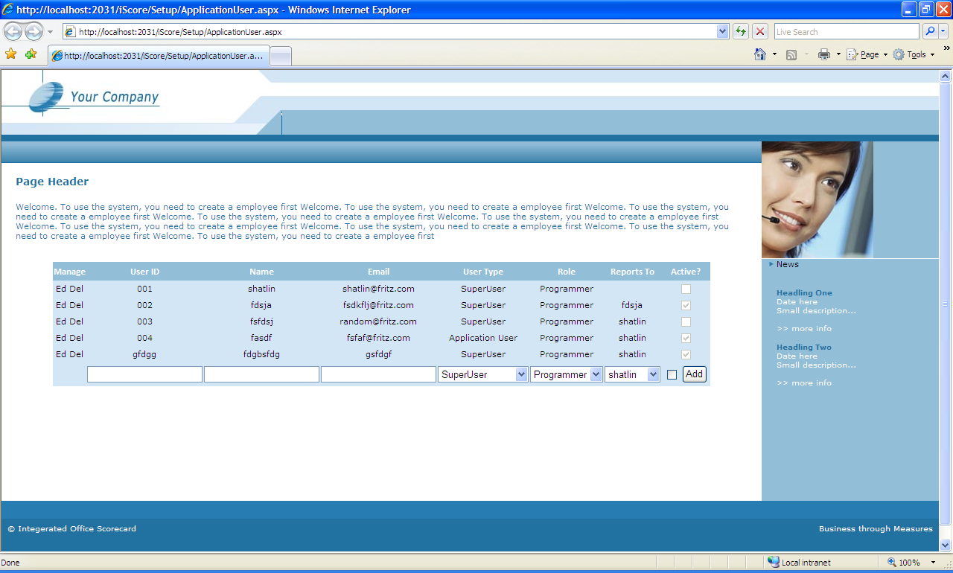

The user interface is to be designed with change in mind. Though each page will be completely designed at developed, leaving no place for rework, the styles of each element is to be maintained in separate css file. All controls provided by asp.net will be kept in a separate skin file so that all pages present the same style to the user.

- There is a section called page header, which will contain information about the page
- Below the header the controls will be shown, which the user can interact with
- Any further operations from the controls, or showing information will be done in the right side of the page ( the blue side).Here the scoring methods, graphs or charts can be displayed.
- Below each control, a panel will be present, which will display result of operations to the user. It can also display errors or exceptions.
- Each page follows a master page which is designed in a separate file.

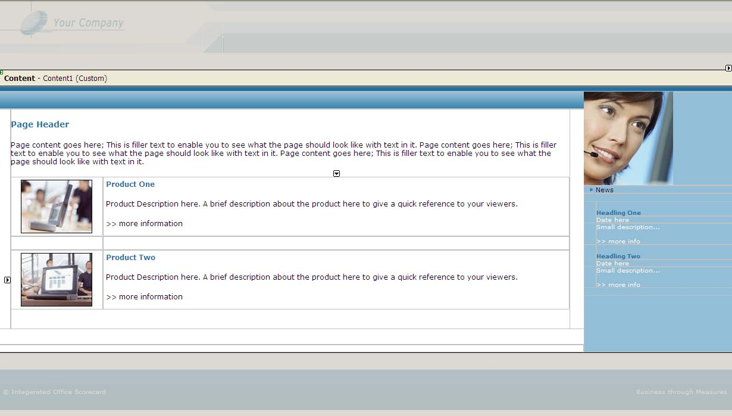

If the whole style of the page is to be changed, it should minimally affect individual pages. It should mainly involve changing the styles.

Before starting any page, a template page should be used as the starting point. Then the template can be modified to put in the content

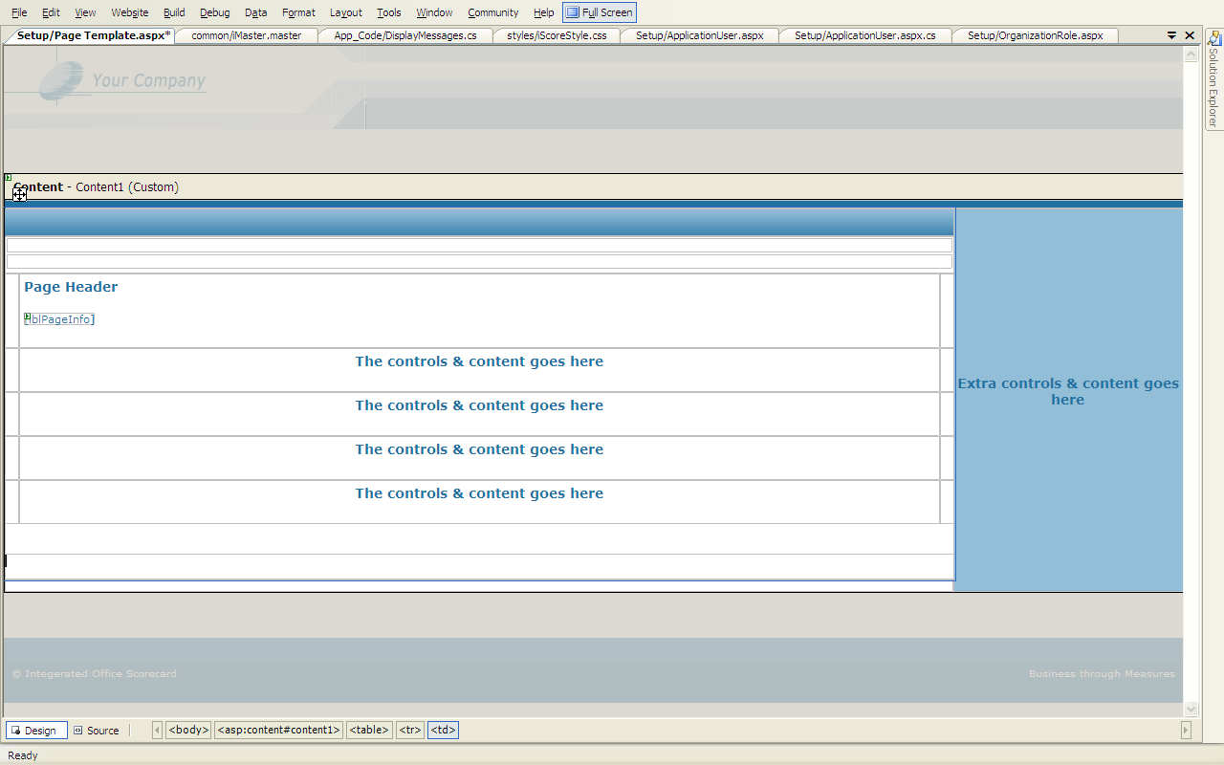

Exception Handling
Exception is handled in the presentation layer. At each layer, whenever exception occurs, the exception will be thrown to the calling layer. It will be handled in the presentation layer. Above each control a panel will be present in the UI, which will report the error to the user. If an exception is not handled, the application should redirect the user to a generic error page.

Coding Conventions
Please use Csharp_Coding standards.pdf as reference for coding standards. Each page and class file should have complete comments when it is completed.

Development Style

Please follow the order below while developing a page. Each step should be documented in a separate file excluding the code)

1) View the requirements & write the operations the page need to perform
2) Design the layout of the page
4) Write test cases that the page should pass.
5) Write validations that need to be satisfied.
6) Write the pseudo code functions in presentation; BL and DL (Include the high level comments). Review if it satisfies the coding conventions.
7) Write the actual functions and write error handling routines to the completion
8) Test the page and document the testing.

Subsystem Designs

This section will detail each subsystem with the requirements that fit into each subsystem, WebPages required, page designs, classes, data and functions and the database tables and fields that would be required.

User Interface Subsystem
User interface subsystem will consist of the web pages and the UI manipulation logic. They can be separated in different folders as per the subsystem that it interacts. For example all the web pages for “competency scorecard” can be stored in a folder called “CS”, so that the whole system is organized properly

The pages that are required will be detailed in the remaining subsystems. For each subsystems what pages are required, how should the layout be will be detailed there. Here, the general look and feel of the UI is given.

User Interface

Web Pages
Web Pages Logic

System Prerequisites

Introduction

The system prerequisites subsystem is divided into three layers. The business logic layer includes the classes and procedures for system prerequisites. Below the business logic layer, the database access layer exists. Business logic layer interacts with the database layer to get the data from the database. The business logic layer will never interact directly with the database directly. It will always request the database layer to get the data. The database layer makes calls to the database and gets or sends the data. Please note that system prerequisites database can be a separate database or exist together with the other subsystems database. Nevertheless, in IOS, this will be a separate database which will be accessed by other systems. Also the business logic layer will work as a web service, serving information to whatever system that requests it.

System Prerequisites

System Prerequisites Database Layer
System Prerequisites business Logic Layer
System Prerequisites Database

Pages required

Req 1: First Logon

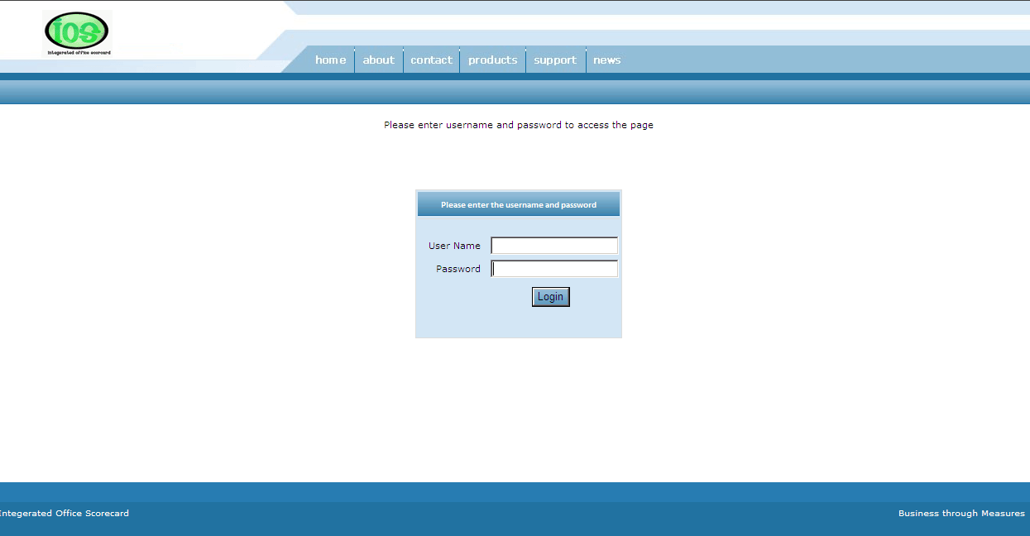

System Prerequisites Data base

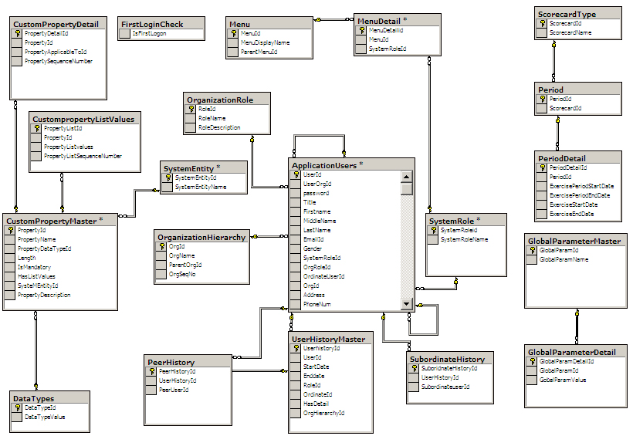

System Prerequisites Class Design

Scorecard management system

Scorecard management system

Scorecard management database layer
Scorecard management business logic layer
Scorecard management database

Introduction
As the whole IOS system revolves around scorecards, this will be most important subsystem. The goal of this subsystem is to create a structure to handle any type of scorecards, at least the three types of scorecards that will be the part of IOS.

WebPages
No WebPages required. This subsystem will output a web part that if rendered on the WebPages will display the scorecard

Functionality Required
- At the header of the scorecard, the scorecard type, the entity for which the scorecard applies should be displayed
- It should be possible for the user to show and hide some columns. Only the columns that are hide able can be hidden. The maximum number of columns will be 20.
- The lowest level of child row must be 10.
- There maximum number of rows in a particular level is 100. As an example,, for the first level. The number of rows can be up to 100.
- A column should display indicator images.
- Each sublevel can be contracted and expanded. The scorecard should act like a tree view.
- All the data comes from database. Scorecard is an instrument of displaying the data.
- Certain scorecard elements should be able to display hyperlinks, clicking which shows some other data related to it.
- Certain scorecard elements should be able to open a comment window clicking which opens a window in which user enters his comments. The entered & saved comments cannot be removed. New comments can be added.
- There can be multiple header rows, to categorize the data.

Database Design
ScorecardMaster

Scorecard id
Scorecard Display name
Number of columns

Scorecard Row Master
Scorecard id
Row id
Row Number
Parent row number

Scorecard Row Detail

Rowid
Row value ( delimited)

Mailing system

All the other systems follow the same structure as the system prerequisites subsystem. Each system will have the business logic layer, database layer and the database. They are given here for completion of information.
Mailing system

Mailing system Database Layer
Mailing system business Logic Layer
Mailing system Database

Performance Management System
Performance Management System
Performance Management Database layer
Performance Management Business Logic Layer
Performance Management Database

Competency management system

Competency management System
Competency Management business logic layer
Competency Management Database
Competency Management Database layer

Balanced scorecard management system

BS management system

BS management database layer
BS management business logic layer
BS management database

Integration management system

Integration Management System
Integration Management database layer
Integration Management business logic layer
Integration Management database

<Describe the environment in which the software will operate, including the hardware platform, operating system and versions, and any other software components or applications with which it must peacefully coexist.>

Design and Implementation Constraints
<Describe any items or issues that will limit the options available to the developers. These might include: corporate or regulatory policies; hardware limitations (timing requirements, memory requirements); interfaces to other applications; specific technologies, tools, and databases to be used; parallel operations; language requirements; communications protocols; security considerations; design conventions or programming standards (for example, if the customer’s organization will be responsible for maintaining the delivered software).>

User Documentation
<List the user documentation components (such as user manuals, on-line help, and tutorials) that will be delivered along with the software. Identify any known user documentation delivery formats or standards.>

Assumptions and Dependencies
<List any assumed factors (as opposed to known facts) that could affect the requirements stated in the SRS. These could include third-party or commercial components that you plan to use, issues around the development or operating environment, or constraints. The project could be affected if these assumptions are incorrect, are not shared, or change. Also identify any dependencies the project has on external factors, such as software components that you intend to reuse from another project, unless they are already documented elsewhere (for example, in the vision and scope document or the project plan).>

System Features
<This template illustrates organizing the functional requirements for the product by system features, the major services provided by the product. You may prefer to organize this section by use case, mode of operation, user class, object class, functional hierarchy, or combinations of these, whatever makes the most logical sense for your product.>

System Feature 1
<Don’t really say “System Feature 1.” State the feature name in just a few words.>
3.1.1 Description and Priority
<Provide a short description of the feature and indicate whether it is of High, Medium, or Low priority. You could also include specific priority component ratings, such as benefit, penalty, cost, and risk (each rated on a relative scale from a low of 1 to a high of 9).>
3.1.2 Stimulus/Response Sequences
<List the sequences of user actions and system responses that stimulate the behavior defined for this feature. These will correspond to the dialog elements associated with use cases.>
3.1.3 Functional Requirements
<Itemize the detailed functional requirements associated with this feature. These are the software capabilities that must be present in order for the user to carry out the services provided by the feature, or to execute the use case. Include how the product should respond to anticipated error conditions or invalid inputs. Requirements should be concise, complete, unambiguous, verifiable, and necessary. Use “TBD” as a placeholder to indicate when necessary information is not yet available.>

<Each requirement should be uniquely identified with a sequence number or a meaningful tag of some kind.>

REQ-1:
REQ-2:

System Feature 2 (and so on)

External Interface Requirements

User Interfaces
<Describe the logical characteristics of each interface between the software product and the users. This may include sample screen images, any GUI standards or product family style guides that are to be followed, screen layout constraints, standard buttons and functions (e.g., help) that will appear on every screen, keyboard shortcuts, error message display standards, and so on. Define the software components for which a user interface is needed. Details of the user interface design should be documented in a separate user interface specification.>

Hardware Interfaces
<Describe the logical and physical characteristics of each interface between the software product and the hardware components of the system. This may include the supported device types, the nature of the data and control interactions between the software and the hardware, and communication protocols to be used.>

Software Interfaces
<Describe the connections between this product and other specific software components (name and version), including databases, operating systems, tools, libraries, and integrated commercial components. Identify the data items or messages coming into the system and going out and describe the purpose of each. Describe the services needed and the nature of communications. Refer to documents that describe detailed application programming interface protocols. Identify data that will be shared across software components. If the data sharing mechanism must be implemented in a specific way (for example, use of a global data area in a multitasking operating system), specify this as an implementation constraint.>

Communications Interfaces
<Describe the requirements associated with any communications functions required by this product, including e-mail, web browser, network server communications protocols, electronic forms, and so on. Define any pertinent message formatting. Identify any communication standards that will be used, such as FTP or HTTP. Specify any communication security or encryption issues, data transfer rates, and synchronization mechanisms.>

Other Nonfunctional Requirements

Performance Requirements
<If there are performance requirements for the product under various circumstances, state them here and explain their rationale, to help the developers understand the intent and make suitable design choices. Specify the timing relationships for real time systems. Make such requirements as specific as possible. You may need to state performance requirements for individual functional requirements or features.>

Safety Requirements
<Specify those requirements that are concerned with possible loss, damage, or harm that could result from the use of the product. Define any safeguards or actions that must be taken, as well as actions that must be prevented. Refer to any external policies or regulations that state safety issues that affect the product’s design or use. Define any safety certifications that must be satisfied.>

Security Requirements
<Specify any requirements regarding security or privacy issues surrounding use of the product or protection of the data used or created by the product. Define any user identity authentication requirements. Refer to any external policies or regulations containing security issues that affect the product. Define any security or privacy certifications that must be satisfied.>

Software Quality Attributes
<Specify any additional quality characteristics for the product that will be important to either the customers or the developers. Some to consider are: adaptability, availability, correctness, flexibility, interoperability, maintainability, portability, reliability, reusability, robustness, testability, and usability. Write these to be specific, quantitative, and verifiable when possible. At the least, clarify the relative preferences for various attributes, such as ease of use over ease of learning.>

Other Requirements
<Define any other requirements not covered elsewhere in the SRS. This might include database requirements, internationalization requirements, legal requirements, reuse objectives for the project, and so on. Add any new sections that are pertinent to the project.>
Appendix A: Glossary
<Define all the terms necessary to properly interpret the SRS, including acronyms and abbreviations. You may wish to build a separate glossary that spans multiple projects or the entire organization, and just include terms specific to a single project in each SRS.>
Appendix B: Analysis Models
<Optionally, include any pertinent analysis models, such as data flow diagrams, class diagrams, state-transition diagrams, or entity-relationship diagrams.>
Appendix C: Issues List
< This is a dynamic list of the open requirements issues that remain to be resolved, including TBDs, pending decisions, information that is needed, conflicts awaiting resolution, and the like.>

